GUI Integration Specifications

Author | Yossi Gottlieb
Version | 0.4 DRAFT
Date | December 14, 2006
File Name | 0000.doc
Revisions History

Date | Author | Change Description
13-Nov-06 | Yossi Gottlieb | Initial version.
22-Nov-06 | Yossi Gottlieb | Added Installer ActiveX chapter.  Added Security chapter.  Moved persistent access rights storage from various ActiveX objects to the Installer ActiveX.
11-Dec-06 | Yossi Gottlieb | Added Diagnostics chapter.
11-Dec-06 | Doron Elgressy | Comments and fixes to diagnostics chapter
14-Dec-06 | Yossi Gottlieb | Incorporated Doron’s changes.

Table of Contents

1. Introduction 4
1.1 Purpose 4
1.2 Applicable Documents 4
1.3 Document Structure 4
2. GUI Overview 5
2.1 Concepts 5
2.2 Session Management 6
2.3 Session Chooser 6
2.4 Service Control Area 6
2.4.1 Remote Control Host 6
2.4.2 Remote Control Viewer 6
2.4.3 File Access Host 6
2.4.4 File Access Client 6
2.4.5 Diagnostics Host 6
2.4.6 Diagnostics Viewer 6
2.5 Service Management 7
Service Parameters 7
2.5.1 Remote Control Viewer 8
2.5.2 Remote Control Host 8
2.5.3 File Access Client 9
2.5.4 File Access Server 9
2.5.5 Log messages 9
3. ActiveX Interfaces 10
3.1 Initialization 10
3.2 Messaging Handling 10
3.3 Remote Control Viewer 11
3.4 Remote Control Host 12
3.5 File Access Client 12
3.6 File Access Server 13
3.7 Diagnostics Viewer 13
3.8 Diagnostics Server 14
4. Security 15
5. Installer ActiveX 16
5.1 First Time Installation 16
5.2 Feature Management Interface 16
5.3 New Feature Installation 16
5.4 Persistent Storage 16
6. Deliverables 18
6.1 Design 18
6.2 Web Deliverable 18
6.3 Messaging Library 18
7. Additional Requirements 19
7.1 Supported Platforms 19
7.2 Internet Explorer Settings 19

Introduction

Purpose
The purpose of this document is to describe the GUI that integrates the Support Space client features, including:
- Remote Control Engine and Viewer
- File Access Server and Client
- Network Streams layer

Applicable Documents
- Remote Control Module Specifications (version 0.3 DRAFT).
- Stream Layer Specifications (version 0.2 DRAFT).
- File Access Specifications (version 0.2 DRAFT).
- Instant Messaging Specifications (version 0.1 DRAFT).

Document Structure
This document is organized as follows:
Chapter 1 – Introduction; describes the document’s purpose and high level structure.
Chapter 2 – GUI Overview; provides an overview of the required GUI, and its high level elements and concepts.
Chapter 3 – ActiveX Interfaces; discusses the way existing functionality is to be packed in ActiveX interfaces, as required by GUI implementation.
Chapter 4 – Security; describes security issues with the ActiveX invocation and ways to address these issues.
Chapter 5 – Installer ActiveX; defines the Installer ActiveX object, which manages all other features (ActiveX controls) that take part in the GUI.
Chapter 6 – Deliverables; defines the required GUI Integration project deliverables.
Chapter 7 – Additional Requirements; lists additional and/or generic requriements.

GUI Overview
The required GUI consists of a single HTML/JavaScript page which consists of multiple areas, as depicted in Figure 1.

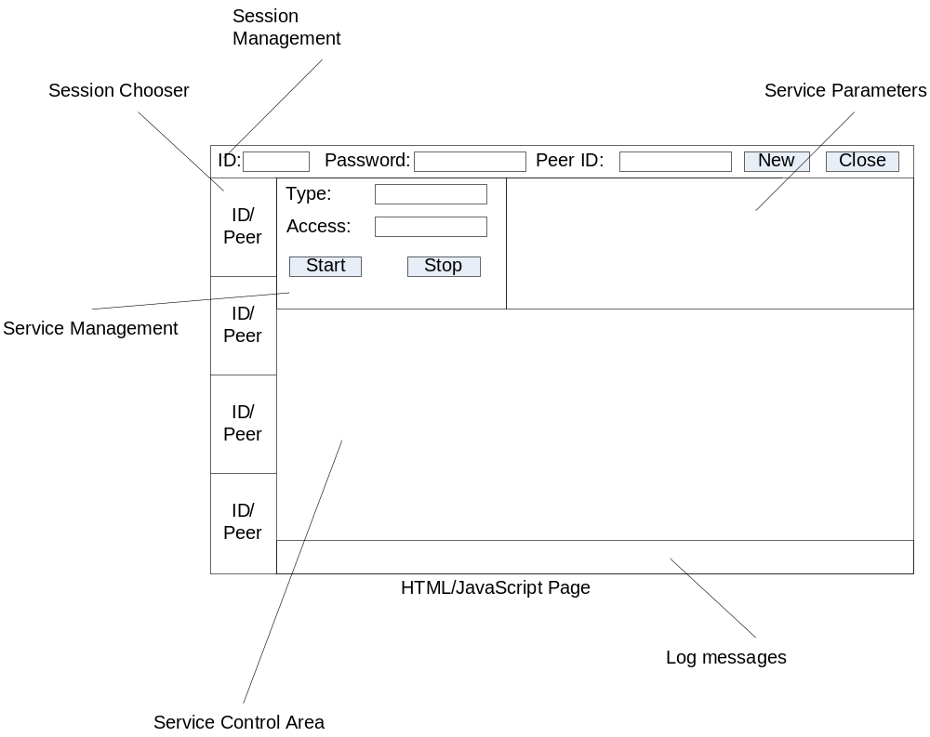
Figure 1: GUI Overview

Concepts
The GUI consists of two main concepts: services and sessions.
Services include Remote Access and File Access (for now). Each service is provided by one peer and used by another. For example: RCHost provides remote control service to RCViewer.
Services are provided between peers in a session. The GUI supports multiple concurrent sessions between peers. Multiple sessions between the same peers are supported. For example: Peer A can maintain a single session with Peer B, and can also maintain multiple sessions with Peer C.

Session Management
The session management area allows the user to establish new sessions with other peers.
In order to establish a session the user needs to provide his/her ID and the peer’s ID, and click [NEW]. This will establish a new session pane, which can be accessed by the session chooser. The current session can also be closed by clicking [CLOSE].
NOTE: The process of establishing a session is an internal JavaScript issue; It does NOT involve ActiveX objects. ActiveX objects are initialized only when a particular service is request over a previously defined session.

Session Chooser
The session chooser area shows all created sessions, and allows the user to switch between them.

Service Control Area
The service control area hosts the ActiveX control that provides the services of the current session.
The content of the service control area depends on the service which is currently in use, as described below.
NOTE: Everything that is displayed in this window is controlled by ActiveX.

Remote Control Host
N/A

Remote Control Viewer
The image of the remote desktop is displayed. No additional GUI elements are provided.

File Access Host
N/A

File Access Client
A dual-pane file list is displayed, providing the user with local and remote disks, directories and files browsing and management interface. In addition, a toolbar and right-click capabilities are provided, allowing the user to perform actions such as file transfer, renaming/removing files, deleting files, etc.
<< TBD: Define this in detail based on the LogMeIn interface >>

Diagnostics Host
N/A

Diagnostics Viewer
A collapsible tree with diagnostics report results is displayed.

<< TBD: Mockup GUI by Doron >>

Service Management
The service management area allows the user to start or stop services. In order to start a service, the user chooses the service type and access level and clicks [START]. To stop the service, the user clicks [STOP].
While the services is started, the [START] button and [TYPE] drop-down menu are grayed out, but the user can still change access levels using the [ACCESS] drop-down menu.
The [TYPE] drop down menu contains the following options:
- Remote Control Host
- Remote Control Viewer
- Remote Control Playback
- File Access Server
- File Access Client
- Diagnostics Server
- Diagnostics Client
The [ACCESS] drop down menu contains the following options:
Value of [TYPE] | Possible [ACCESS] values
Remote Control Host  Remote Control Viewer | View Only  Full Control
Remote Control Playback | N/A
File Access Server  File Access Client | Read Only  Upload Only  Full Access
File Access Server  File Access Client | Allowed to execute  Not allowed to execute

Service Parameters
The Service Parameters area only appears after a service has been started, and provides the ability to control the service. The elements that appear in this area depend on the activated service, as described below.

Remote Control Viewer
The remote control viewer exposes the following elements, as depicted in Figure 1 below:
Element Name | Type | Description
Recording File Name | Text Field + Buttons | The name of the session recording file, along with [START] and [STOP] buttons to control recording.
Display Mode | Drop-down List | One of:  - Scaling [Default]  - Full Screen  - Scrolling
Colors | Drop-down List | One of:  - Optimal [Default]  - 32 bit  - 16 bit  - 8 bit  - 4 bit
Encoding | Drop-down list | All options that are available in the RCTest GUI.
[ Additional Fields] |  | All additional fields that are available in the current RCTest GUI should be supported.

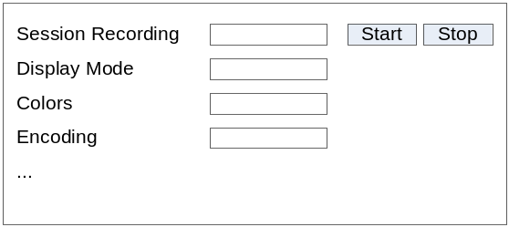
Figure 2: Remote Control Viewer Service Parameters

Remote Control Host
The remote control viewer exposes the following elements:
Element Name | Type | Description
Recording File Name | Text Field + Buttons | The name of the session recording file, along with [START] and [STOP] buttons to control recording.
Protect Window | Checkbox | Toggles protection of the Internet Explorer window in which the page is displayed.

File Access Client
N/A

File Access Server
Element Name | Type | Description
Log File Name | Text Field + Buttons | The name of a session log file, along with [START] and [STOP] buttons to control logging.

Log messages
The log messages area serves as a console where error, informative and diagnostic messages are logged.

ActiveX Interfaces
This chapter describes the interfaces that the ActiveX components should expose to the JavaScript code.
Two main patterns have been identified among the interfaces between the JavaScript and ActiveX:
- ActiveX interfaces that provide their own GUI interaction – Remote Control Viewer and File Access Client.
- ActiveX interfaces that are not visible to the user – Remote Control Host and File Access Server.

Initialization
An ActiveX object is initialized when the service it provides is started. During initialization it is provided with the following information:
Parameter | Description
User ID | Identifies the local user.
Password | Used for authenticating the local user with the relay server, if needed.
Peer ID | Identifies the remote peer.
Relay server address | Specifies the IP address or hostname of the relay server. The UDP and TCP ports used to communicate with it are hard-coded in the ActiveX object.
LogMessage | A JavaScript callback function which implements on-screen logging in the designated area.
SendMessage | A JavaScript callback function which sends a specified IM message to the remote peer.

NOTE: All these parameters correspond to parameters defined in the Stream Layer Specification, and which the Stream Factory class requires when negotiating and establishing a new connection.

Messaging Handling
The ActiveX object needs to implement mechanisms for receiving and sending messages, in order to satisfy the Stream Factory interface (which is described in the Stream Layer Specifications document).
Transmission of messages is implemented in JavaScript, and provided to the ActiveX object as a callback function (see SendMessage above).
Handling of incoming messages is implemented in JavaScript as well. The ActiveX object is required to implement the following method, which is used by the JavaScript to deliver incoming messages:
Method | Parameters | Description
HandleMessage() | Message Body

The JavaScript is responsible for filtering messages. It only handles messages received from a known peer, and which contain a Subject (or other fields to be chosen later) which indicates the message has been sent from an ActiveX object.

Remote Control Viewer
The Remote Control Viewer ActiveX displays a remote desktop on the Service Control Area. It does not provide any other GUI controls, and exposes the following interfaces:
Method | Parameters | Description
SetSessionMode() | Mode  State | See Remote Control Module Specifications document.
SetDisplayMode() | DisplayMode | See above.
SetSessionOpts() | Encoding  ColorDepth  UseCopyRectEncoding  UseCacheEncoding  ZipTightCompression  JpegQuality | See above.
SetSessionRecording | FileName  Mode (On/Off) | Toggles session recording mode. When enabled, recording takes place into the specified file name.  SECURITY NOTE: The specified file is created in a hard-coded directory, and the file name is cleaned up to prevent creation of files outside this directory (e.g. using relative paths, such as “..\..\filename.ext”).
SetNotificationCallback | NotificationCallback | Define a JavaScript callback function to be invoked by the RCViewer notification methods.
StartPlayback() | File Name | Begin playback of a recorded session. See above security note regarding file name handling.
SetDelayFactor() | Factor | Controls playback delay factor when Playback() is in progress.
Start() |  | Begin remote control session.
Stop() |  | End remote control or playback session.

Remote Control Host
The Remote Control Host ActiveX provides remote peers with access to the local machine. It operates as a GUI-less ActiveX object.
Unlike the Remote Control Viewer, the Host object must operate as a singleton, since multiple concurrent remote users must be connected to the same RCHost object.
The object is required to provide the following interfaces:
Method | Parameters | Description
SetSessionMode() | Mode  State | See Remote Control Module Specifications document.
SetSessionRecording | FileName  Mode (On/Off) | Toggles session recording mode. When enabled, recording takes place into the specified file name.  SECURITY NOTE: The specified file is created in a hard-coded directory, and the file name is cleaned up to prevent creation of files outside this directory (e.g. using relative paths, such as “..\..\filename.ext”).
SetNotificationCallback | NotificationCallback | Define a JavaScript callback function to be invoked by the RCViewer notification methods.
Start() |  | Begin remote control session.
Stop() |  | End remote control or playback session.

File Access Client
The File Access Client ActiveX provides access to the peer’s File Access Server. It implements all the necessary GUI, as follows:
- Side-by-side panes that list drives, folders and files on the local computer and the remote computer (through the File Access Server). The user can navigate both panes individually.
- Right-click action menu which allows various actions to take place on the selected file.
- Toolbar that allows various actions to take place.
NOTE: Unlike the GUI elements specified so far, which rely on JavaScript/ActiveX collaboration, this ActiveX object should be self contained and implement its own GUI. The reasons for this decision are the complexity of this GUI, and the security issues presented by a scriptable object that provides access to atomic local and remote file operations.
<< TBD: Define the details of this GUI, based on the LogMeIn interface and/or additional features and ideas. >>
The object is required to provide the following interfaces:
Method | Parameters | Description
SetNotificationCallback | NotificationCallback | Define a JavaScript callback function to be invoked by the FileAccessClient notification methods (in particular to notify session start/end).
Start() |  | Begin remote file access session.
Stop() |  | End remote file access session.

File Access Server
The File Access Server ActiveX provides remote peers with access to local drives, folders and files. It operates as a GUI-less ActiveX object.
Multiple File Access Server objects can provide concurrent service to remote users, so unlike the Remote Control Host object, it does NOT require to operate as a singleton.
The object is required to provide the following interfaces:
Method | Parameters | Description
SetAuthorization() | Mode | Specify authorization mode: Read Only, Upload Only, Full Access.  This should map to the more granular authorization mechanism provided by FileAccessServer, as described in the File Access Specifications.
SetNotificationCallback | NotificationCallback | See above.
Start() |  | Begin remote file access session.
Stop() |  | End remote file access session.

Diagnostics Viewer
The Diagnostics Viewer ActiveX provides access to a remote Diagnostics Host. It operates as a GUI-less ActiveX object, and exposes the interfaces described in the Diagnostics Module Specifications document.

Diagnostics Server
The Diagnostics Server provides remote Diagnostics Viewers with the ability to perform local diagnostic actions. It operates as a GUI-less ActiveX object.
Multiple Diagnostics Server objects can provide concurrent service to remote users..
The object is required to provide the following interfaces:
Method | Parameters | Description
SetNotificationCallback | NotificationCallback | See above.
Start() |  | Begin diagnostics session.
Stop() |  | End diagnostics session.

Security
All ActiveX controls described in this document should be marked “Safe for Scripting’’, since they are accessed from JavaScript.
This has severe security implications, since attackers can directly or indirectly exploit the functionality provided by these controls. Direct exploitation may include taking over a computer by establishing a remote control session to it. Indirect exploitation may include modifying the default access rights of a supporter, and later using the supporter’s account to gain escalated access rights on the computer.
In order to solve these, issues all ActiveX controls should only be accessible to JavaScript from the supportspace.com domain. See the following link for details:
http://msdn.microsoft.com/archive/default.asp?url=/archive/en-us/samples/internet/components/sitelock/default.asp

Installer ActiveX
The purpose of the Installer ActiveX is to manage the process and life-cycle of different Support Space client features, which are implemented as standalone ActiveX modules.

First Time Installation
The Installer ActiveX itself is installed as a regular ActiveX, which involves Internet Explorer requiring the user to confirm.

Feature Management Interface
The Installer ActiveX provides an interface which is used by JavaScript code to manage installed features, as follows:
Method | Parameters | Description
GetInstallerVersion() | n/a | Returns the Installer’s own version.  This is also used by JavaScript to validate that the Installer ActiveX is ready.
GetFeatureID | Feature Name  Feature Version | Returns the GUI of the installed feature (based on name and version), or a null response if the feature is not installed.
InstallFeature | Feature Name  Feature Version | Installs a new feature, as described below.

New Feature Installation
The primary function of the Installer ActiveX is to provide installation of new features (new ActiveX objects).
New feature installation is triggered by JavaScript, which provides the required feature name and feature version.
The Installer ActiveX uses this information and a URL template to construct the name of the file to be downloaded. For example, feature “RemoteControl” and version 1 may provide a URL such as:
https://download.supportspace.com/features/RemoteControl_1.cab.
The actual format of the downloaded file may not necessarily be CAB, but it should provide archiving of multiple files, compression and digital signature capabilities.
After the file is downloaded, its digital signature is verified and it is extracted in a predefined location based on its name and version. All OCX files it contained are registered.

Persistent Storage
The Installer ActiveX also provides infrastructure for persistent storage of information. This infrastructure is used by various JavaScript elements to store default access rights the user may grant to specific supporters. These access rights can then be retrieved by the JavaScript and passed on to the appropriate feature ActiveX when initialized.
The following interface should be used:
Method | Parameters | Description
IsItemSet() | Key | Returns a Boolean result, representing whether or not the specified item has been set.
SetItem() | Key  Value | Create a new item with the specified key and value.  If the item exists, its value is modified.
GetItem() | Key | Returns the previously set value of an item.
DelItem() | Key | Deletes an item.

Deliverables

Design
A detailed design document should be provided.

Web Deliverable
The GUI integration should be delivered as an HTML page and set of ActiveX objects which implement the above functionality.
The deliverable should be installed on a web server, in order to provide real-world experience (in terms of browser warning messages, etc.).

Messaging Library
The above specifications make several references to a messaging library that provides peers with the capability to send and receive messages.
The selected library is JSJaC (JavaScript Jabber Client Library: http://jsjac.jabberstudio.org/), which will be used to communicate with a Jabber instant messaging server using the HTTP Binding method.

Additional Requirements

Supported Platforms
The GUI Integration project should support Internet Explorer 6.x and 7.x on Windows 2000, Windows XP and Windows Vista.

Internet Explorer Settings
The GUI Integration project should work on default Internet Explorer settings. In particular, it should not require security settings to be more relaxed.
NOTE: During development and initial testing the above statement may be disregarded, as the HTML page is likely to be delivered from a file:// URL and may require weaker domain restrictions in order to contact the IM service.

